**Cloud computing**

Cloud computing is a way of computing, via the [Internet](http://en.wikipedia.org/wiki/Internet), that broadly shares computer resources instead of using [software](http://en.wikipedia.org/wiki/Computer_software) or [storage](http://en.wikipedia.org/wiki/Computer_data_storage) on a local [PC](http://en.wikipedia.org/wiki/Personal_computer).

Cloud is a very important next step in the evolution of the datacenter and virtualization is one of the key enablers of cloud computing.

Cloud computing consists of different **layers**:

* Client
* Application
* Platform
* Infrastructure
* Server

[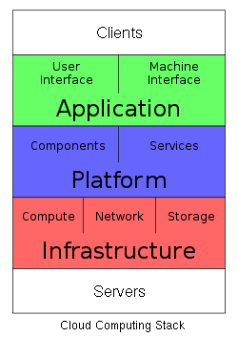](http://en.wikipedia.org/wiki/File:Cloud_Computing_Stack.svg)

Most people associate virtualization with servers, but application virtualization is really heating up.

Application virtualization offers capabilities like dynamic provisioning, which allows end user to connect to their applications from multiple users.

Cloud has five essential characteristics:

* on-demand self-service
* broad network access
* resource pooling
* rapid elasticity
* measured service.

In general, cloud computing customers do not own the physical infrastructure, instead avoiding [capital expenditure](http://en.wikipedia.org/wiki/Capital_expenditure) by renting usage from a third-party provider. They consume resources [as a service](http://en.wikipedia.org/wiki/Everything_as_a_service) and pay only for resources that they use.

Cloud computing users can avoid [capital expenditure](http://en.wikipedia.org/wiki/Capital_expenditure) (CapEx) on hardware, software, and services when they pay a provider only for what they use

Architecture

Cloud architecture, the [systems architecture](http://en.wikipedia.org/wiki/Systems_architecture) of the [software systems](http://en.wikipedia.org/wiki/Software_systems) involved in the delivery of cloud computing, typically involves multiple cloud components communicating with each other over [application programming interfaces](http://en.wikipedia.org/wiki/Application_programming_interface), usually [web services](http://en.wikipedia.org/wiki/Web_service). This closely resembles the [Unix philosophy](http://en.wikipedia.org/wiki/Unix_philosophy) of having multiple programs each doing one thing well and working together over universal interfaces. Complexity is controlled and the resulting systems are more manageable than their [monolithic](http://en.wikipedia.org/wiki/Monolithic_system) counterparts.

**Platform-as-a-Service** To some, cloud computing platforms have been affectionately called Platform-as-a-Service, or PaaS (not to be confused with that Easter Egg coloring kit of the same name). Cloud computing platforms facilitate and ease the deployment of applications into the cloud, limiting the cost and complexity by cutting the need to buy and manage hardware and software. As cloud computing continues to gather steam and more VARs and their clients are looking to design, develop, test, deploy and host apps in the cloud, a robust, flexible platform has become a must-have.

**Infrastructure-as-a-Service** Cloud infrastructure may not sound sexy on the surface, but peel the onion a little bit and realize the ease and the cost savings of deploying, using and monitoring and managing apps in the cloud and it gets a bit more attractive. Everyone does it a little differently, but at the core, the companies that made infrastructure vendors all have one thing in common: They rock the party, and by that we mean they have the tools and offerings necessary to embrace and leverage the cloud to its fullest potential. Some of these are well known, others were just established within the last 12 months.

**Storage-as-a-Service** is, for many solution providers, their entry into cloud computing. It features all the hallmarks of a cloud computing offering, including the use of a shared infrastructure outside the customers' [data center](http://www.crn.com/encyclopedia/defineterm.jhtml?term=data%20center&x=&y=) to store primary or backup data, and some form of [virtualization](http://www.crn.com/encyclopedia/defineterm.jhtml?term=virtualization&x=&y=) to integrate that [infrastructure](http://www.crn.com/encyclopedia/defineterm.jhtml?term=infrastructure&x=&y=) seamlessly with existing storage and backup schemes. And since nearly every customer is looking for a better way to store data and back it up, there are plenty of opportunities to talk about off-site managed storage, whether or not the term "cloud" comes up.

**Productivity Application Vendor:**

Within many businesses, the adoption of cloud-computing productivity applications generally 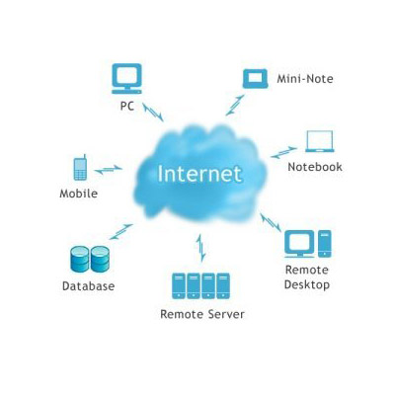went like this:

**Sales manager:** "We need to implement a CRM system. How long will that take?"

**IT manager:** "Can you get back to me in about a year? We're very backlogged on projects."

**Sales manager:** "Uh, OK."

And so the sales manager went off and subscribed to Salesforce.com's CRM service, adopting cloud computing as a way to get around the IT department. That's been changing, however, as IT managers come to understand the potential benefits of using cloud-based personal productivity applications, from lower infrastructure costs, to improved flexibility, to eliminating time-consuming software implementations and upgrades. While the ranks of on-demand software vendors grow daily,

Cloud Security Vendor

 No doubt, the last few years have been pivotal in driving the cloud security phenomenon. And there doesn’t seem to be any sign of slowdown in 2010.

In addition to cloud-based antivirus, spam filters and Web scanning engines, security companies are now launching cloud-based DLP and authentication and log management technologies.

About Doyenz:

The Doyenz ShadowCloud platform can help solution providers restore servers in the cloud for low-cost disaster recovery, failover and data migration.

The company allows the building and testing of servers as virtual machines using VMware's ESXi server virtualization software and StorageCraft's ShadowProtect backup software for physical environments. These servers can then be restored and deployed in minutes at the [client](http://www.crn.com/encyclopedia/defineterm.jhtml?term=client&x=&y=) site, or on managed hosted infrastructure from players such as Savvis or Rackspace.

Customers pay the equivalent to about one hour per month of the solution provider's consulting fee, while solution providers get recurring revenue and better margins for their investment.

IDC makes a distinction between "**cloud services**" and "**cloud computing**." Cloud services, according to the market research firm, are "consumer and business products, services, and solutions that are delivered and consumed in real-time over the Internet." In contrast, cloud computing as defined by IDC is the infrastructure or "stack" for development and deployment that enables the "real-time delivery of products, services, and solutions over the Internet."